## Tumour growth model functional form choice

Based on the available evidence tumour growth appeared to follow an exponential type curve. However, a simple exponential growth model was deemed to be insufficient to explain observed characteristics of tumour growth; growth slows down as a tumour grows towards maximum possible size and growth rates vary by individual tumour. Using Gompertz and logistic functions allows for an exponential growth that slows towards a maximum size. These functions were therefore deemed to be more appropriate than the simple logistic function for simulating tumour growth. The screening model output will not be sensitive to the choice between Gompertz and logistic because both show near equivalent patterns of growth (see Figure A3.1). The main region of difference close to the maximum tumour size is nearly irrelevant to screening models because almost all tumours are detected by screening or clinical signs before this size.

**Figure A3.1: Gompertz and logistic growth functions**

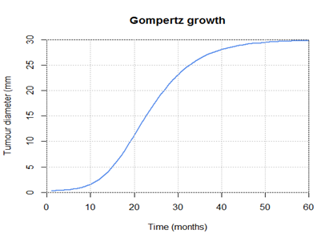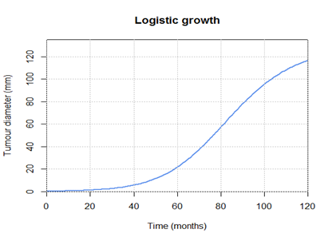

An extension of continuous growth natural history models was considered to allow varying tumour growth rates by parameterising the distribution of growth rates in the population. This may be achieved by fitting more complex statistical models to cancer registry data from before and after screening programme initiation. A distribution such as normal or log-normal was assumed for individual tumour growth rates. Random draws from the specified distribution can then be used in the growth simulation. This can more accurately reflect tumour growth across a population of cancer cases and therefore more accurately predict the effect of changing the screening programme. Therefore, this study used Norwegian cancer registry data from before and after the start of a population-based screening programme [5]. A logistic growth function was selected with individual variation in growth rates with a lognormal distribution using parameter values in Table A3.1.

**Table A3.1: Cancer growth rate parameters**

|  |  |
| --- | --- |
| $V_{max}$ (maximum tumour volume) | mm3 |
| (initial tumour size, in theory one cell but in practice may be set to anything) | mm3 |
| (mean growth rate) | 1.07 |
| $α_{2}$ (growth rate variance) | 1.31 |

### Invasive cancers

Table A3.2 reports the probability of a tumour of a given size (maximum diameter in mm) being assigned to specific NPI category conditional on the tumour already being an invasive cancer.

**Table A1.2 Probability of NPI category membership conditional on tumour size**

|  |  |  |  |
| --- | --- | --- | --- |
| Size (mm) | NPI I | NPI II | NPI III |
| 1-5 | 0.76 | 0.22 | 0.02 |
| 6-10 | 0.7 | 0.27 | 0.02 |
| 11-15 | 0.55 | 0.43 | 0.02 |
| 16-20 | 0.4 | 0.55 | 0.05 |
| 20-30 | 0.07 | 0.64 | 0.29 |
| > 30 | 0.06 | 0.5 | 0.44 |

### Advanced breast cancer

Table A3.3 displays the probability of tumour being at an advanced stage at diagnosis conditional on the size of the tumour (maximum diameter in mm).

**Table A3.3 Tumour size and probability of presenting at advanced (TNM: Stage IV) stage**

|  |  |
| --- | --- |
| Tumour Size (mm, max diameter) | Probability of presenting at advanced stage |
| <25 | 0.046 |
| 35 | 0.087 |
| 45 | 0.110 |
| 55 | 0.127 |
| 65 | 0.143 |
| 75+ | 0.160 |